Instructions for abstract preparation for AOCRP6

J.L. First¹, P.L. Second² and J.C. Third²

¹Department of ……, University of Somewhere, City, Postcode, Country
²Department of …., University of Elsewhere, City, Postcode, Country
Keywords: first, second, third, fourth, fifth.
Corresponding author email: j.first@somewhere.edu

The abstract should be in double column (like this example) and ONE page long (any additional page will be automatically deleted). Use A4 page set-up and make all margins (top, bottom, left, right) 20 mm wide. Use 10 pt Calibri font (except for the title which should be in 12 pt bold and in sentence case). Centre the title, the authors’ names, the addresses, and keywords and contact email address. Please compose a title that clearly and succinctly describes the content of your work to maximise its impact.
Start each paragraph, except the first, with an indent. Justify the body of the text both left and right. Do not use page numbers. Uniformity of abstract style makes the work much easier to digest! Keywords are there to draw attention to your abstract, and to help the organisers allocate the presentation to the most appropriate session.
A good abstract might be structured as follows:
- One or two sentences to provide a basic introduction to the field.
- A few sentences of more detailed background followed by a statement of the general problem being addressed.
- A few sentences summarising the main result.
- A few sentences explaining what this result means, potentially contrasting with previous findings.
- A few sentences placing the result in a more general context and what the broader implications are.
Use clear English to write your abstract, with an emphasis on describing what is new and why it should attract the attention of the audience.
Figures can be in colour or in black and white. Ensure that Figures and Tables have a caption and that they are numbered consecutively.

Table 1. Comparison between theoretical predictions and experimental measurements.
Month | Measured density (μg/m3) | Predicted density (μg/m3)
Feb | 0.4 | 0.4711
Jun | 2.4 | 1.528×10⁴

References should be made in the style (Dickenson, 2005), Marr and Morrissey (2010) or as Curtis et al (1996). Examples of references are shown below.
Section headings can be used, but they do take up valuable space: the same can be said of equations.
Abstract review
The abstracts will be reviewed by the scientific program committee. Abstracts which do not fulfil the standards will be rejected. Please avoid submitting abstracts containing only future results.
Accepted abstracts will be placed on the conference website/app and provided to conference attendees. Abstract titles and author lists will be listed in the conference handbook/app.
Participants should not make requests for oral presentation of several papers on similar subjects. We recommend submitting only the most general paper for oral presentation and the others for poster presentation.
The abstract should be submitted in pdf format through the AOCRP6 website. The deadline for abstract submission is 07th of Aug 2022.

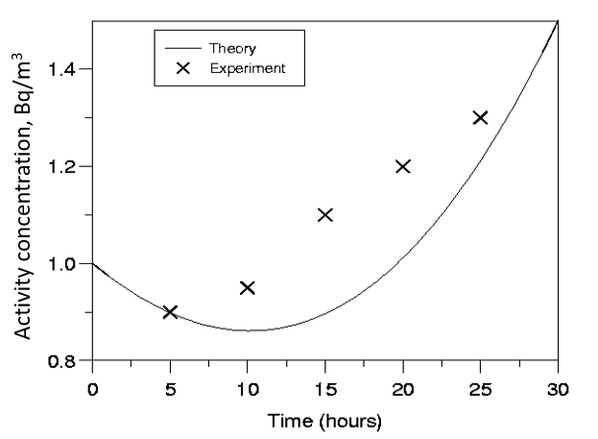

Figure 1. This is a comparison between theory and experimental data.

This work was supported by the National Council for Research under grant JB/005.

Author, A., Coauthor, B. and Coauthor, C. (1996) Proc. Conf. Title, World Scientific.
Author, B. (2005) Title of Book, Publisher Name, Publisher City.
Author, A. and Coauthor, B. (2010) Journal Title 210, 123-126.

